**A Comparative Analysis of Machine Learning Algorithms**

**Indrashis Mitra, Souvik Karmakar, Sudeshna Dutta, Kinjal Sarkar and Pratyay Basu**

**Guided by: Prof.** [**Kananbala Ray**](mailto:kbrayfet@kiit.ac.in)

***Abstract -*** India is a major player in the global pharmaceutical sector. There is a large hub of budding engineers and scientists in the nation that can take it to the next level. Antiretroviral drugs manufactured in India currently account for more than 80% of the world's AIDS medicine supply. However, people in India are taking desperate steps to keep loved ones alive as a disastrous spike of new coronavirus infections overwhelms the country's health-care infrastructure. They are turning to dubious medical therapies in some circumstances, and to the underground market for life-saving pharmaceuticals in others. Hence our project aims to solve this by developing a medicine recommendation system so that pharmacists can know in advance what medicines are being bought together the most, and keep stocks accordingly. We do not recommend which medicine is to be taken, rather the focus is on finding the drug combinations bought frequently together so that an idea can be had of the most-selling medicines; thus, keeping their stock replenished would eliminate the black market, help to earn profits and help the customers. Furthermore, the focus is also on an exploratory analysis of different classifiers for DNA classification to understand how they can be modified to suit a particular requirement.

***Index Terms -*** medicine, recommendation, DNA, classification, Apriori, ECLAT, supervised learning

1. INTRODUCTION

Healthcare has become one of the world's fastest-growing industries, undergoing a total transformation and revolution on a worldwide scale. It has an essential role in enhancing people's health and well-being all over the world[1]. Our main objective is to employ machine learning to help in the supply of medicines. Using the Apriori algorithm's support metrics, we plan to develop a recommendation system for the medicine that a particular customer is most likely to buy, resulting in a win - win for both the customer and the shop owner: the customer gets the required medicine they want at all times and does not have to deal with the annoyances of out of stock medicines; and the pharmacist learns the particular combination of medicines that is made available easily, wiping out the need for out-of-stock medicines. We also intend to compare the Apriori and Eclat algorithms to see what the differences are between the two recommendation systems.

1. LITERATURE REVIEW

All across the world, healthcare plays an important part in improving people's health status and well-being. In healthcare data classification, ambiguity and high-dimensionality are two factors that add to the difficulty [3]. Patients, physicians, and medical treatments are all recorded in the healthcare big data set, which grows in volume so quickly that typical data analytics tools are not able to keep up with it and evaluate it effectively. Some machine learning technologies are used in conjunction with the big data analytics framework as a means of addressing these issues. Data mining has emerged as a critical study issue in the advancement of computing applications in health care and biology [5]. Several large tech companies, including IBM and Google, have developed machine learning tools that can help doctors uncover novel treatment options for patients. Precision medicine is a significant concept in this discussion since it involves developing new ways to treat complex disorders and uncovering the underlying causes. However, even though several semi-supervised approaches have been presented to give additional training data, automatically produced labels are frequently too noisy to adequately retrain models [2]. In this project we have tried to make things easier in whatever way we can. Yoo et al. investigated the benefits and drawbacks of using data mining techniques in the biomedical field[6].To increase the performance of recurrent neural networks (RNNs) for anomaly detection, Yadav et al. employed ordinary differential equations (ODEs) to generate time series[7].

III. BASIC CONCEPTS

R. Agrawal and R. Srikant presented the Apriori algorithm in 1994 for locating frequent itemsets in a dataset for boolean association rules. Name of the algorithm is Apriori because it uses prior knowledge of frequent itemset properties. An iterative approach or level-wise search is done to find k+1 itemsets by using k-frequent itemsets.Apriori property is used to improve the efficiency of level-wise generation of frequent itemsets by reducing the search space.

Equivalence Class Clustering and Bottom-up Lattice Traversal is the acronym for the ECLAT algorithm. It is one of the most widely used Association Rule mining techniques. It is a faster and more scalable version of the Apriori algorithm.

While the Apriori algorithm works horizontally, mimicking the Breadth-First Search of a graph, the ECLAT algorithm works vertically, mimicking the Depth-First Search of a graph.

Classification is a Supervised Learning technique that is used to identify the category of new observations on the basis of training data. In classification, a program learns from the given dataset or observations and then classifies new observations into a number of classes or groups.

The most commonly bought medicines was clear through Fig 1, while the results of the Apriori and ECLAT model was depicted through Fig 2 and Fig 3 respectively.

IV. IMPLEMENTATION AND RESULTS

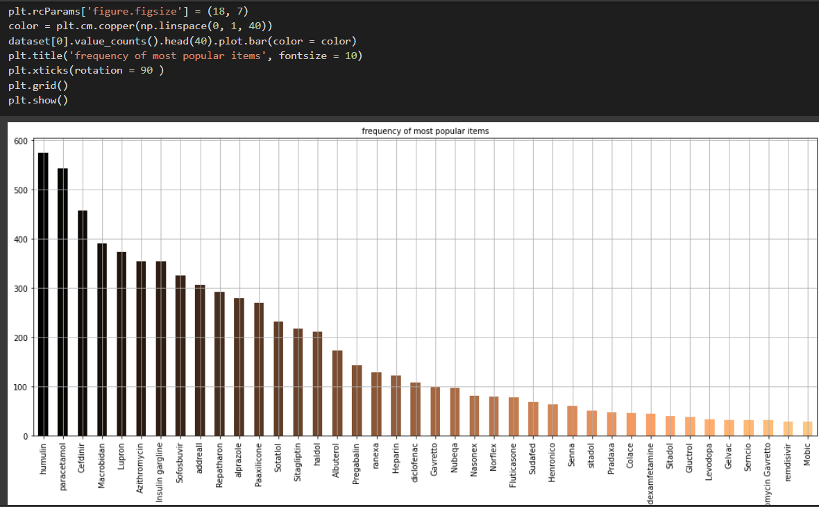

*Fig 1 - Frequency of most popular medicines*

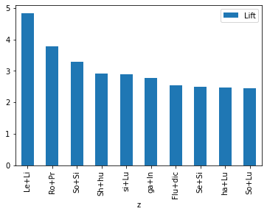

*Fig 2- Visual depiction of top 10 medicines bought together - Apriori model result*

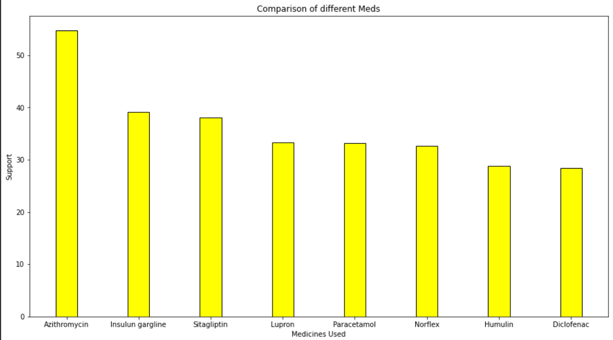

*Fig 3 - Most commonly bought medicines - ECLAT model result*

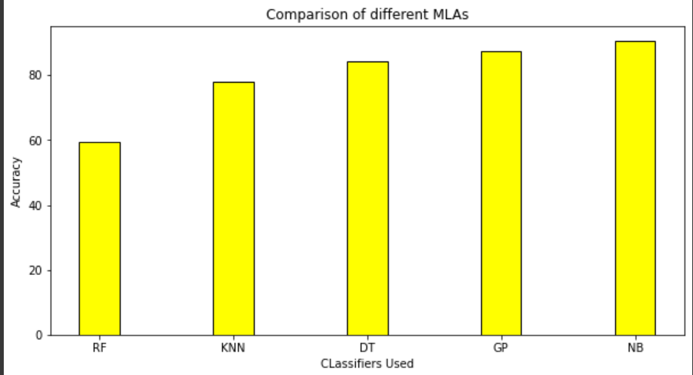

*Fig 4 - Comparison of classifiers*

The best model for this particular classification is found to be the Naive-Bayesian algorithm with an accuracy of 90.625%,as visible in Fig 4.

1. CONCLUSION

We have mainly focused on two objectives. The first one was a medicine recommendation system that will be helpful for the healthcare sector. People won’t have to face the problem of unavailable medicines, since the stores will be stocked well in advance since they can know which medicines are most likely to be bought. Moreover, the economy will be helped since the medical black market will be eliminated as medicines are readily available so there is no shortage, thus no scope of dishonest people to dupe others by profiteering from selling medicines at exorbitant rates to needy people. Secondly, our focus is on the study and comparison of various classifiers. We have taken 5 classifiers and processed the same dataset containing DNA sequences through each of them, so that we can understand which classifier works best in our case.

VI. REFERENCES

[1].J. Bouwens, “Embracing Change: The healthcare industry focuses on new growth drivers and leadership requirements”,2017.

[2]. "Intro to Machine Learning | Udacity." Intro to Machine Learning | Udacity. Accessed April 27, 2016.

[3]. Thanh Nguyen, Abbas Khosravi, Douglas Creighton, Saeid Nahavandi, Classification of healthcare data using genetic fuzzy logic system and wavelets, Expert Systems with Applications, Volume 42, Issue 4, Pages 2184-2197,2015,

[4]. Schölkopf, Bernhard, Christopher J. C. Burges, and Alexander J. Smola,Advances in Kernel Methods: Support Vector Learning. Cambridge, MA: MIT Press, 1999.

[5]. Witten, I. H., and Eibe Frank. Data Mining: Practical Machine Learning Tools and Techniques. Amsterdam: Morgan Kaufman, 2005

[6]. Zhiyong Ma, Juncheng Yang, Taixia Zhang, Fan Liu. (2016). An Improved Eclat Algorithm for Mining Association Rules Based on Increased Search Strategy. International Journal of Database Theory and Application, 9(5), 251-266

[7]. Yoo I, Alafaireet P, Marinov M, Pena-Hernandez K, Gopidi R, Chang JF, et al. Data mining in healthcare and biomedicine: a survey of the literature. J Med Syst ; 36:2431–48,2012.

[8]. Yadav M, Malhotra P, Vig L, Sriram K, Shroff G. Ode-augmented training improves anomaly detection in sensor data from machines. arXiv preprint arXiv:1605.01534,pp:1–5,2016.

[9]. Hastie, Trevor, Robert Tibshirani, and J. H. Friedman. The Elements of Statistical Learning: Data Mining, Inference, and Prediction: With 200 Full-color Illustrations. New York: Springer, 2001

[10]. O.Stephen et.al.,”An Efficient Deep Learning Approach to Pneumonia Classification in Healthcare”,Journal of Healthcare Engineering ,Volume 2019.